Lake Committee Meeting Minutes
May 2, 2024
Start 7:30PM End 8:47PM

Attending: Mike Freedman, Lauren Bianchi, John O’Connor, John DiNiro, Michael Colasurdo, Jodi Colasurdo, Joanne Machalaba, Maria Lynch, Michael Lynch, Barry Silbiger, Scott Rothbart, Bill Roberto, Benjamin Peretto.

Please be respectful of the committee, committee chairs and all committee members.

Old Business
Meeting minutes from April meeting- approved.
New Business
~Lake Condition- Lake chair met with Chris Hanlon from Lake Management Sciences (our new applicator) on site 4/23/24. Existing conditions and future treatments were discussed. LMS and PH to alternate visits every two weeks. So a consultant checks our conditions twice a month.
Lake chair attended recent COLA meeting. DEP presenter discussed HABs and the state’s response. HABs have been present for 30 billion years. The NJDEP started testing them in 2019. Paragon Services also gave a presentation on strategies for lake remediation. PS are currently remediating Mountain Lake’s water bodies, for and through the municipality. Lake Chairs and other WML reps had a conference with Paragon Services. There will be an onsite meeting with PS next week. The committee will be investigating formal remediation options. Is a lake depth survey available?
The trickle feed pump for the beach 2 stream has arrived. Our first alum shipment arrived. Alum feeding will commence before any weed treatment is applied.
The portable water analyzer purchase was delayed as a NJDEP loaner was requested. No loaner is available and our analyzer will be purchased shortly per approved motion.

~Dam monthly readings from January, February and March will be graphed and correlated shortly. A formal (6 year) dam inspection is due this year and will be scheduled toward the end of our season.

~Fishing club- minutes attached. Newsletter blurb attached. Bluegills and Fathead minnows will be stocked this month for up to $10k, motion approved. Carp control was discussed baiting and corralling vs. bow and pole fishing. Fishing club to offer education for successful Carp fishing tactics.

~Boat registration- sub-committee forming Lauren Bianchi chair. First meeting May 6th at 7pm. Four pontoons on waiting list. Two were accommodated this week. Hopefully other two spots can be found after- ‘all boats in’ date.

~Bill R. asked about Tilcon donating $7500. Is payment made to appease WML? According to site manager monies to be allocated $500 to go to festival day and $500 to camp balance to go to lake for lake management. Lake chairs should be involved in future discussions.
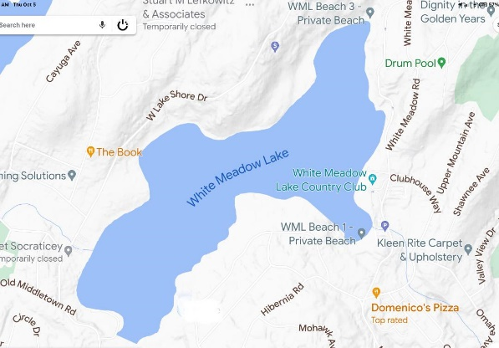
Minutes submitted by Maria Lynch
Approved by: Joanne Machalaba-OIC

