Lake Committee Meeting Minutes
June 4, 2024
Start 7:30PM End 9:09PM

Attending: Mike Freedman, Lauren Bianchi, John O’Connor, John DiNiro, , Michael Colasurdo, Joanne Machalaba, Maria Lynch, Michael Lynch, Barry Silbiger, Scott Rothbart, Alan Zenkert, John Pieploi and John Zito.

Please be respectful of the committee, committee chairs and all committee members.

Old Business
Meeting minutes from May meeting- approved.
New Business
~Lake Condition- An early season HAB event was evident during Chris Hanlon from Lake Management Sciences visit. It was decided by lake consultants and lake committee to treat the bloom in hopes of a HAB free season. Also, treated early season weeds with Sonar. After last month’s meeting with lake services contractor Paragon Services they promised additional information and a price for surveying our lake bed. Mike L. emailed them today- we have not received any follow up. The portable water analyzer has been received by Barry S. and initial readings are encouraging. Monthly reports promised from the RT watershed committee have not been received in months. Alum feed rate was 150 gals/ day during the algae treatment consulted all and reduced to 75 gals/ day will monitor turbidity for signs to adjust rate.

~Dam monthly readings for April and May not yet available. A formal (6 year) dam inspection is due this year and will be scheduled toward the end of our season.

~Fishing club- minutes attached. Newsletter blurb attached. FC plans to have fish tanks set up for Saturday and Sunday of Festival Day Weekend- volunteers needed.

~Boat registration- sub-committee- minutes attached. All boats should be in spots. Can we accommodate the 2 boats on the waiting list? Barry S. is going to check availability. Expanding our dock capacity was discussed. Mike F. and Mike L. are going into capacity increase feasibility at beach 3 and maintenance and repair to existing docks.

~Miscellaneous- Additional solar lights required for newer dock sections. We discussed winter boat and summer trailer storage options.
NEXT MEETING Tuesday, July 2nd, 2024

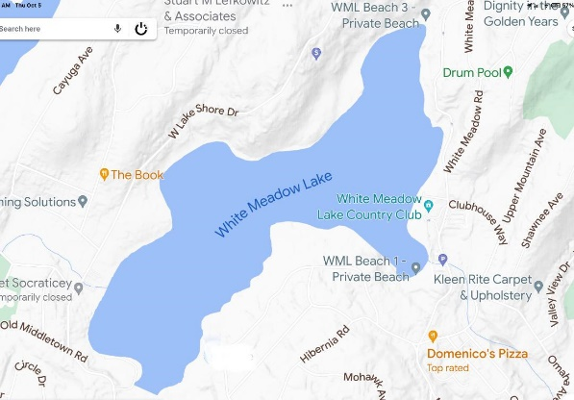
Minutes submitted by Maria Lynch
Approved by OIC

